# Documentation for Grahamstown Grub Stop Website

## Section A

### Task2

1. Security features

2. Authentication system

3. log file

PHP script for writing a log file:

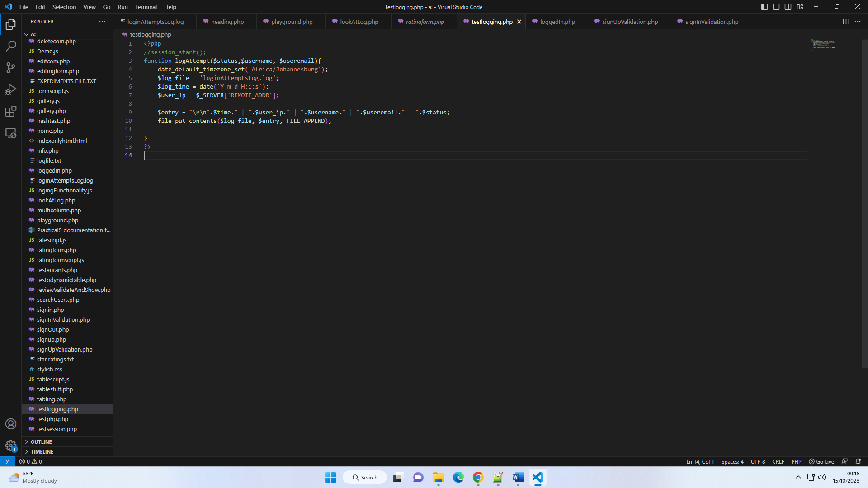

This code is found in “testlogging.php”

The method logAttempt is called from signin validation and signup validation files to log successful and unsuccessful user activities.

The logfile (loginAttemptsLog.log) can be displayed to admin users on the website in the account manager tab.

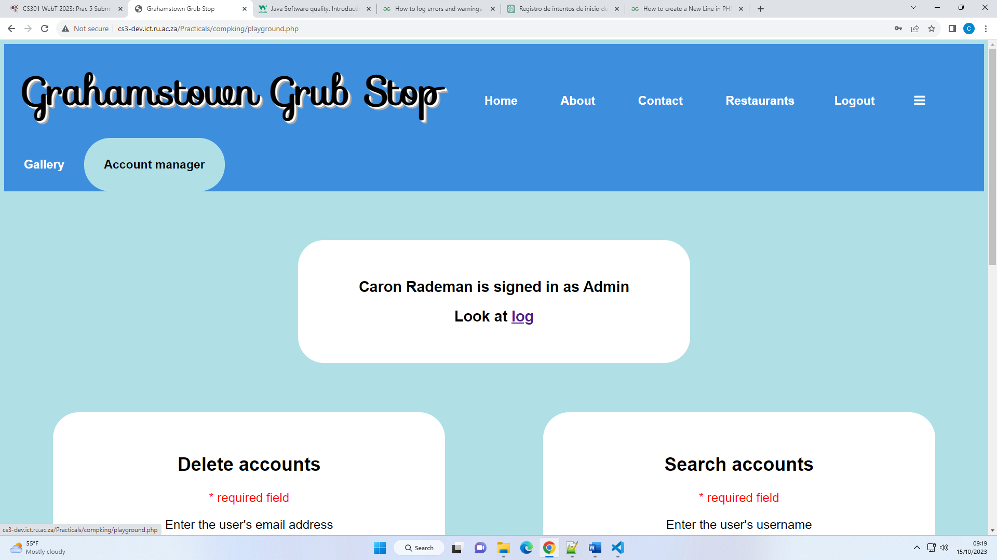

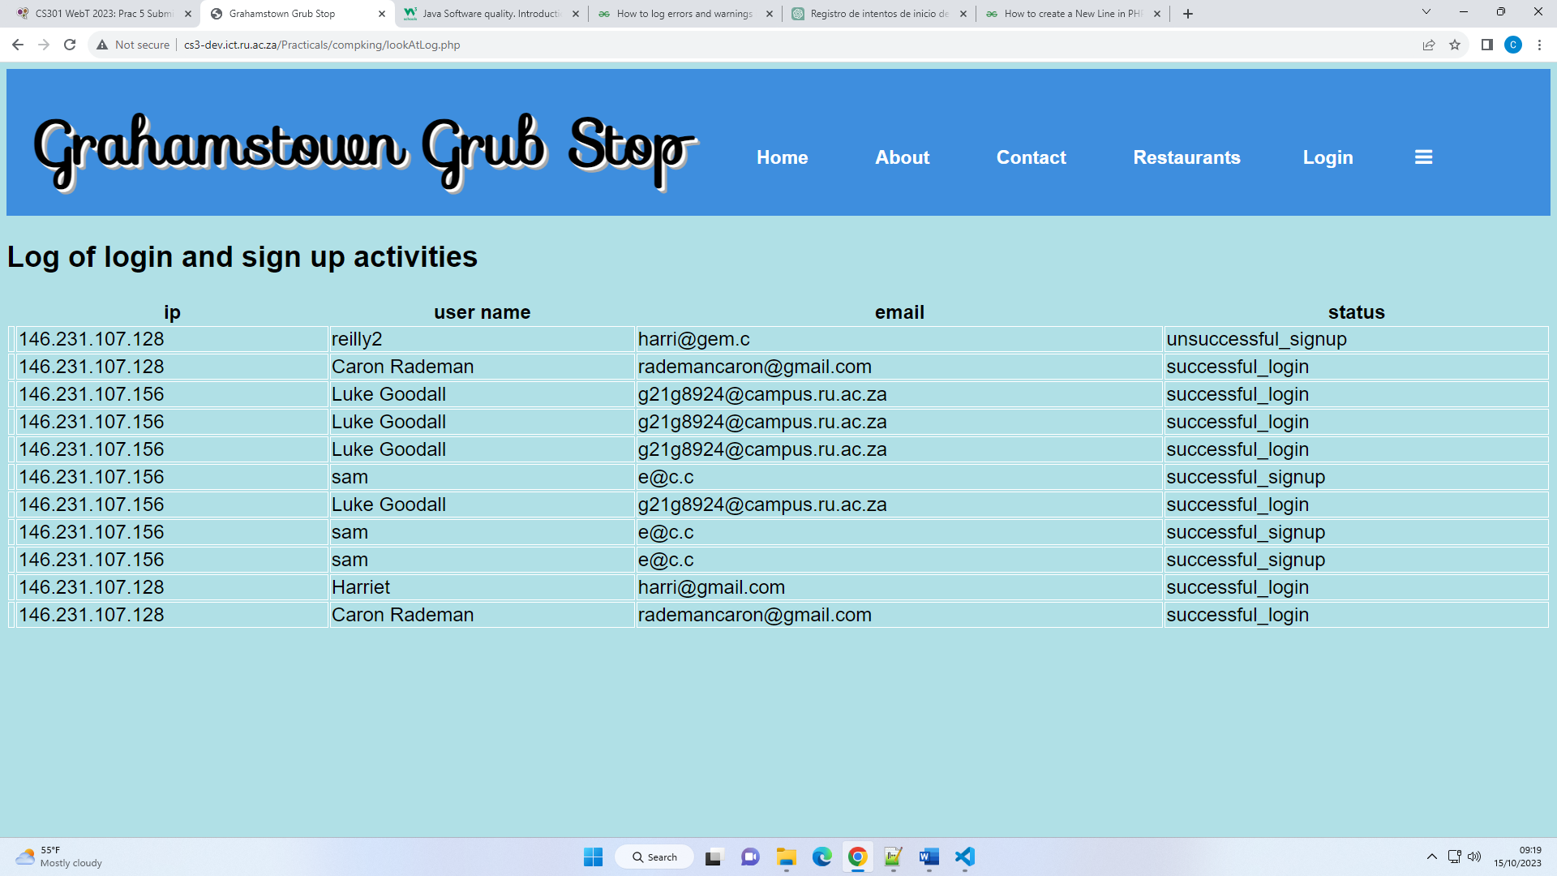

4. security features

a. front end:

* javascript password and email hints:

For instance, on the contact page, we highlight as the user has met each requirement.

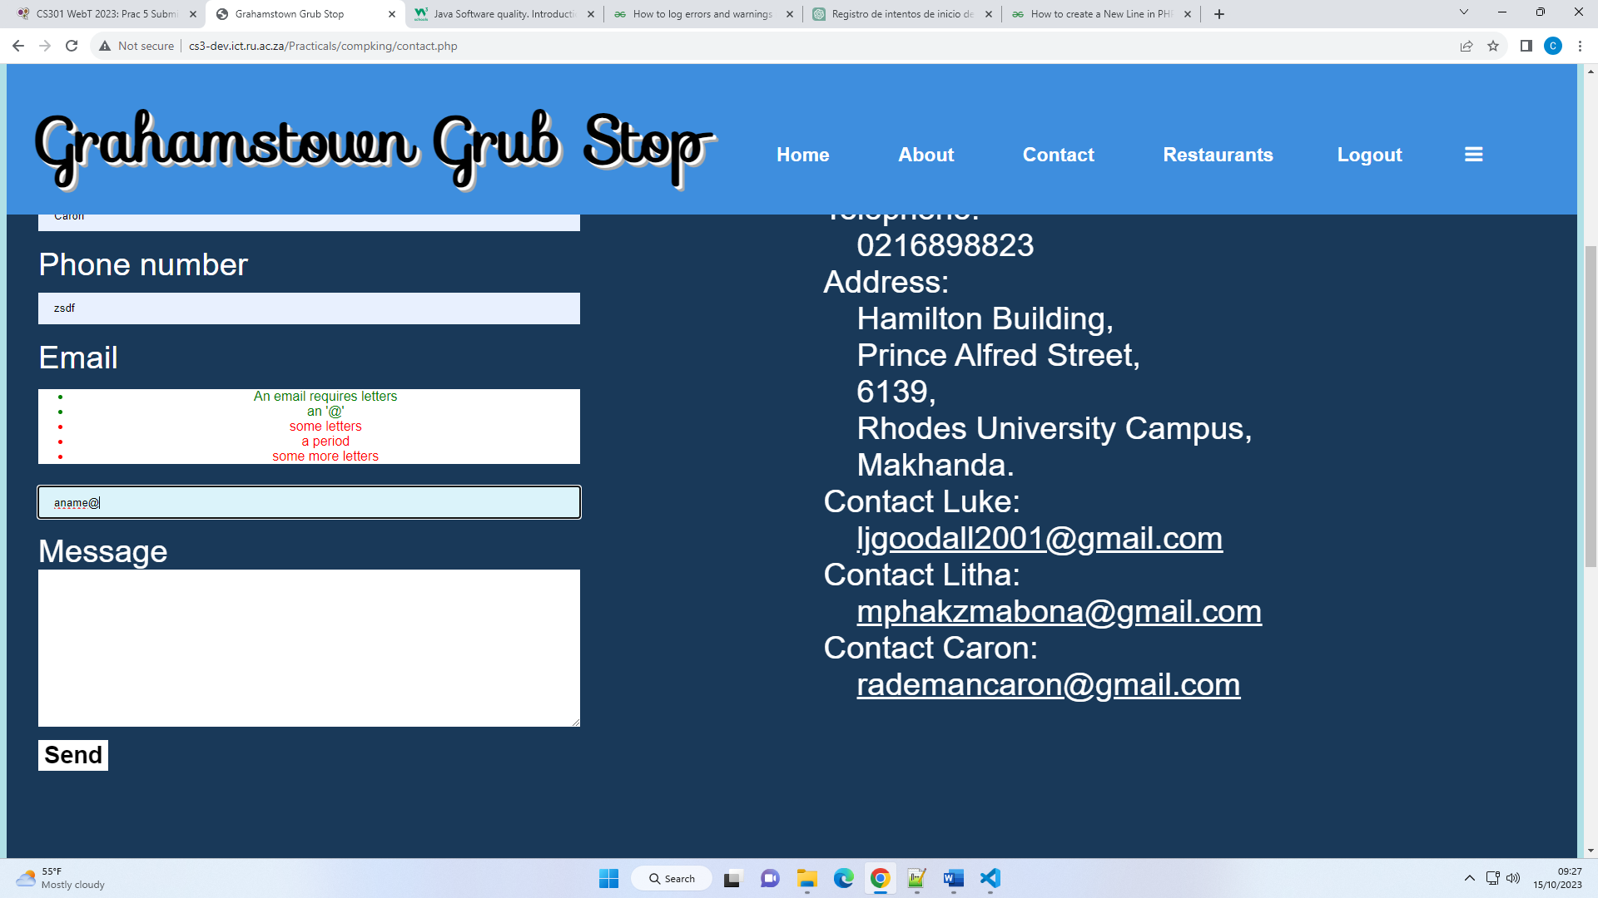

b. back end

* PHP form validation:

To prevent SQL injection, we sanitise input using htmlspecialchars, trim, stripslashes and we used prepared statements to insert user input into the database. For instance, the contact form validation. 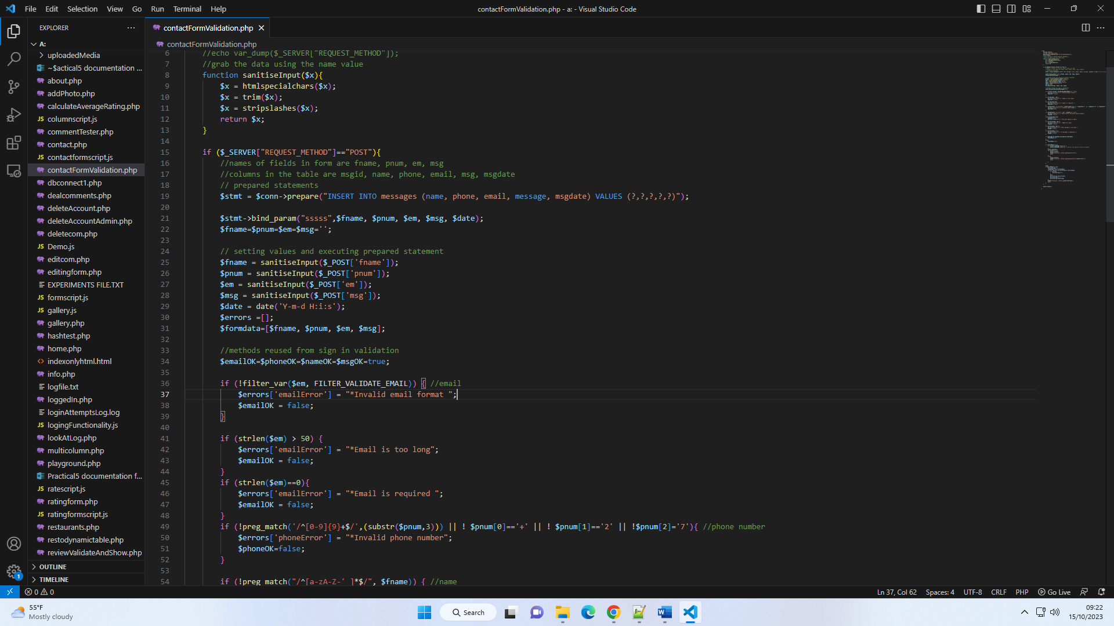

We check each input requirement and display error messages pertaining to each field.

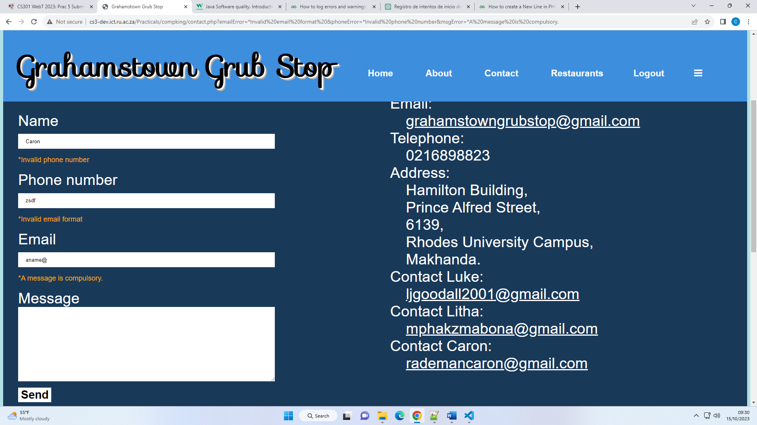

* Different user privileges:

We used a technique of only echoing out sections that pertain to specific user privileges—use session variables to check if user is admin, logged in casual user, or not logged in.

For instance, only a user that is not logged in can see reviews but cannot see the review form to leave a review.

View of a user not logged in: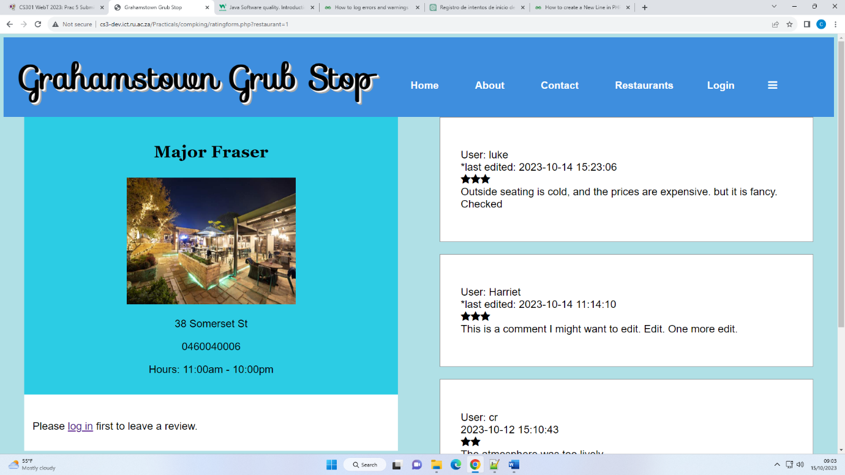

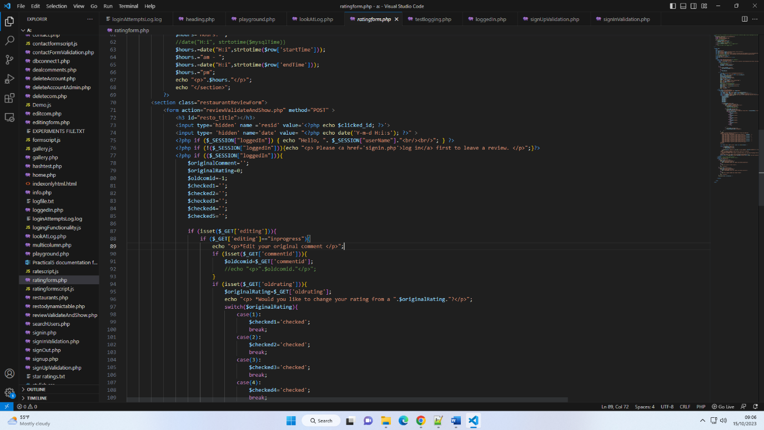

View of a user who is logged in. Logged in users can leave reviews, and delete and edit their comments.

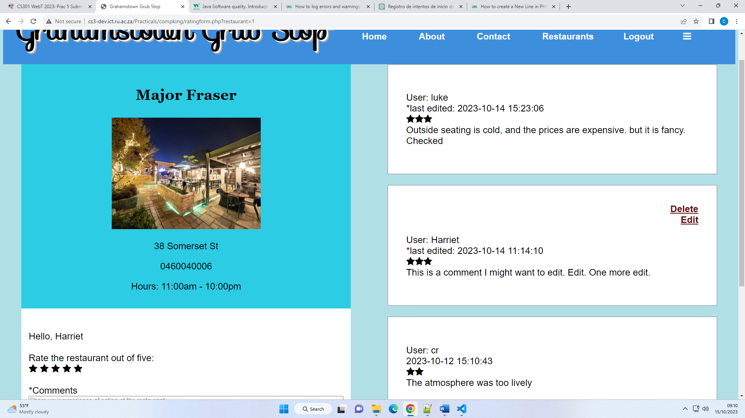

Admin users can delete all users’ comments:

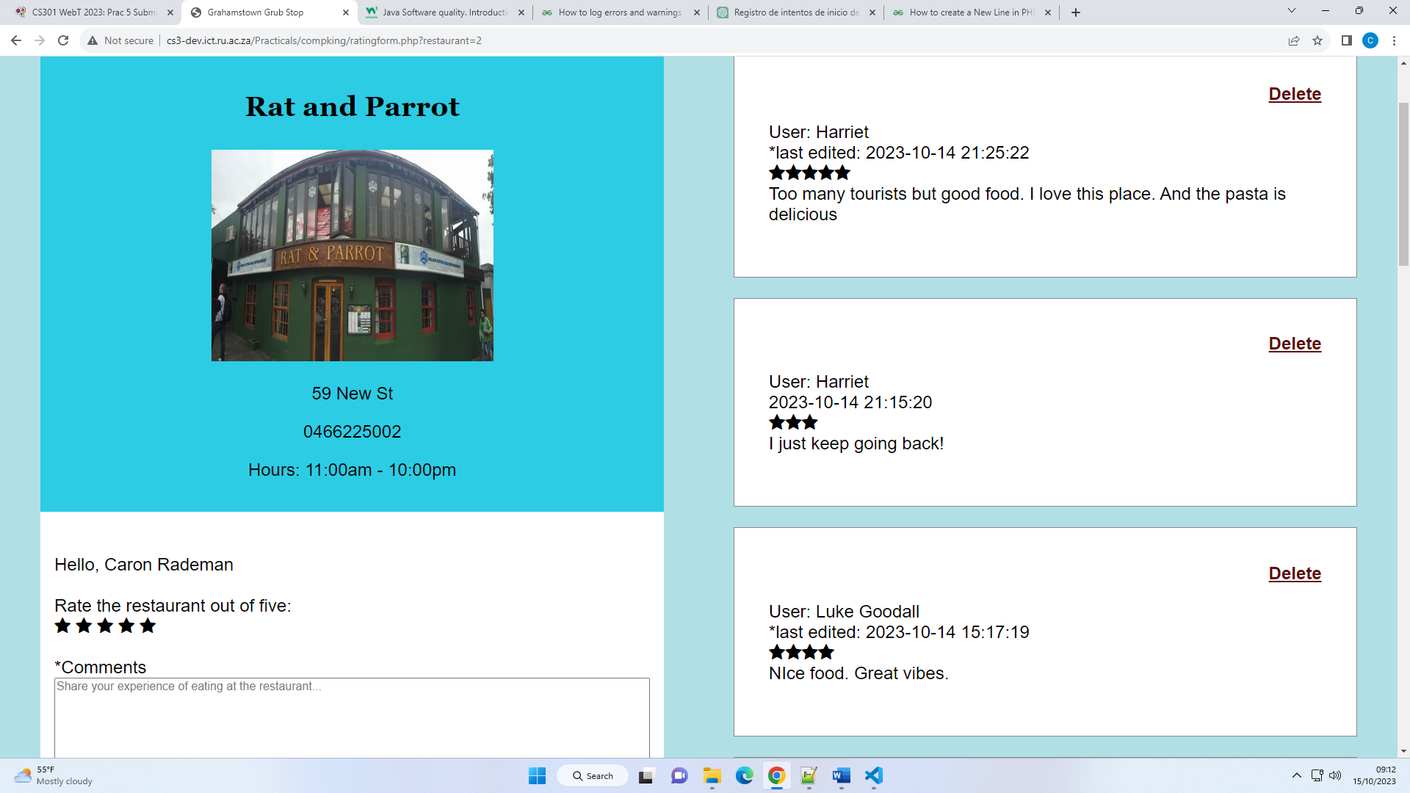

5. extra features

## Section B

### Task3

**Personal account of tasks**

Luke

Litha

Caron:

|  |  |  |
| --- | --- | --- |
| Section/practical | Code files with code contribution | Description of contribution |
| html | See html found in restaurants.php, about.php,  contact.php,  ratingform.php | Restaurant table, about page |
| css |  | Restaurant table, contact page, about page |
| js |  | Contact form, review form pop up on the review page |
| database |  | Created restaurants table, review table and contact message table. Handled data entry of reviews and contact messages. Handled fetching of data to display reviews/comments, restaurants in restaurant table. |
| Security |  | Create and display of logfile to record user login/register attempts.  Prepared statements and sanitising inputs from contact form and review form for entry before entry into database tables.  Display of review form based on whether user is logged in or not. |

## Section C

a.

b.

c.

d.

e.

f.

g.

h.

i.